CITY OF CHEHALIS
PARKS & RECREATION
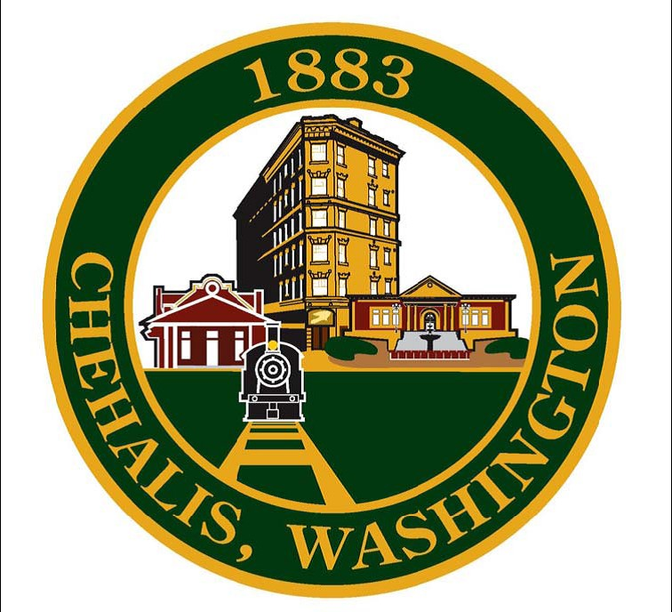
Volunteer Interest Form
Name/Name of Business or Group: Click or tap here to enter text.
Email: Click or tap here to enter text.
Phone #: Click or tap here to enter text.
Area interested in serving (Park name or city location): Click or tap here to enter text.
Please describe your type of service activity, including type of equipment/supplies needed:
Click or tap here to enter text.

What is the age range of your volunteers? Click or tap here to enter text.

What are the proposed dates?Click or tap here to enter text.

What is the min/max number of volunteers you anticipate? Click or tap here to enter text.

Do your volunteers have special skills or talents that could serve a park project? Click or tap here to enter text.

Once completed, please email this form to Recreation@ci.chehalis.wa.us

