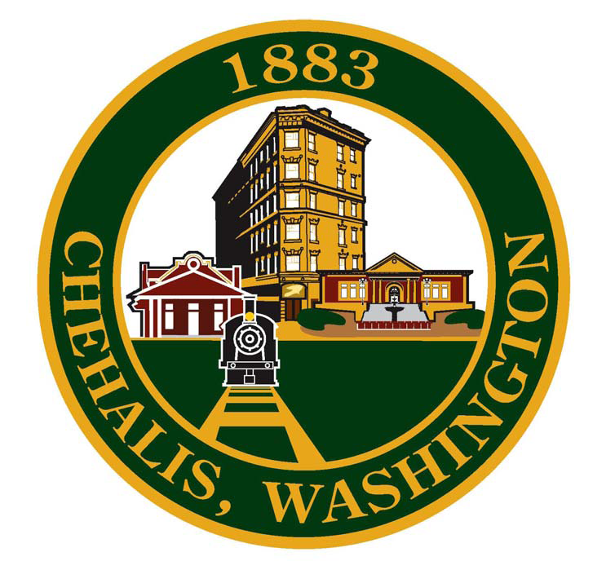
CITY OF CHEHALIS
350 N. Market Boulevard, Room 101
Chehalis, Washington 98532
(360) 345-1042
www.ci.chehalis.wa.us

ACCOUNTANT/PAYROLL
Supplemental Application Questions

Applicant Name: ________________________________________

- Describe your experience with performing general accounting and financial reporting. Please provide specific examples.

- Briefly summarize how governmental and private sector accounting differ?

- List the accounting classes you have taken, and the credit hours earned for each.

- Describe your experience with maintaining an automated payroll and benefits system. Provide detailed examples and specific tasks you were responsible.

- Describe your experience with researching payroll issues that required payroll system modification or update. What was changed and why?

- Describe common key internal controls for payroll administration?

- How would you rate your proficiency level with Microsoft Excel? Provide examples of your experiences using Excel.

- The Fair Labor Standards Act (FLSA) requires payment of overtime to nonexempt employees for the time they work over 40 hours during a 7-day work week. You notice one of the City’s collective bargaining contract states payment of overtime when employee has more than 8 hours in a day including paid leaves. This is obviously not the same requirement as FLSA. Should you pay overtime under the FLSA rule or under the collective bargaining contract? Why?

