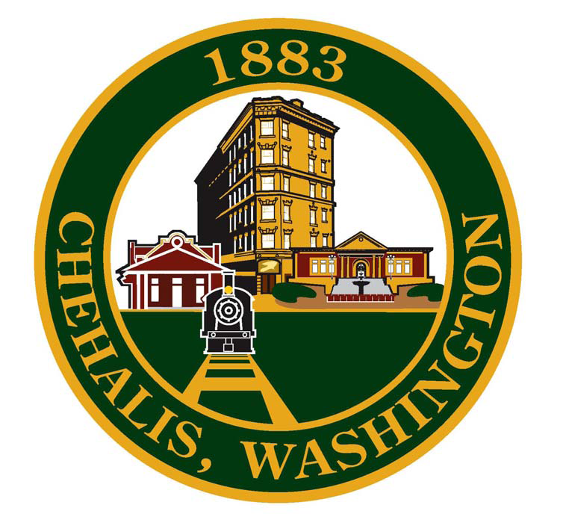
CITY OF CHEHALIS
350 N. Market Boulevard, Room 101
Chehalis, Washington 98532
(360) 345-1042
www.ci.chehalis.wa.us

Accounting Intern
Supplemental Application Instructions

Applicant Name: __________________________________
- Are you currently enrolled full-time as an undergraduate or graduate student in an accredited college/university?
- Yes
- No

- Do you have or are you pursuing a degree in Accounting?
- Have a degree in Accounting and pursing a graduate degree
- Pursuing a degree in Accounting
- Pursing a non-accounting degree

- What year of school are you in?
- Sophomore
- Junior
- Senior
- Graduate program

- Do you have a valid driver’s license?
- Yes
- No

- Which of the following best describes your knowledge of Governmental Accounting?
- None
- Limited – Understand governmental structure.
- Intermediate – Taken an early level class.
- Advanced – Worked in governmental accounting.

- Which of the following best describes your proficiency with Microsoft Excel?
- None
- Beginner
- Intermediate
- Advance

- Briefly describe your experience using Excel.

- Briefly tell us about your experience in Accounting industry other than school.

- What is you Grade Point Average (GPA) in accounting classes?

- What is your availability Monday-Friday, 8am – 5pm?

- Is there anything you would like us to know about yourself? (Optional)

