Chapter X

HISTORIC PRESERVATION

Introduction
Chehalis residents value the strong sense of community and history in the City of Chehalis. Visitors to the area can see the care that residents and local government put into the town, restoring historic buildings, supporting local businesses, and maintaining the charm of rural Western Washington. The locale of the city has historically been a center of commerce, from agricultural farms to fishing, and even to railways. Thanks to its geographic features and cultural past, the city has long been a place of growth. This chapter of the City of Chehalis Comprehensive Plan will be used to guide city leaders and staff in the development of the city that honors the history and culture of the area. The goals and policies in this chapter define the expectations and vision for the future of Chehalis and offer guidance in decisions of regulations and their implementation. The goals and policies here are intended to maintain and encourage development of the charm and local character using methods of urban design and historic preservation.
The City of Chehalis as we know it today began in 1851 when the Saunders family settled in the region, with the eventual name of the city being inspired by the local Indigenous community’s word for “shifting and shining sands.” Initially, the waterways and abundant lands around them were what drew the settlers, and later, the introduction of the Northern Pacific Railroad encouraged more settlers and their institutions. Formed around the railroads, the Chehalis downtown began on Main Street, but was forced to shift and change as fires swept through the area, destroying much of the original buildings. When building the historic structures we see in the city today, a variety of architectural styles, such as Italianate and Queen Anne in the central business district, and neo-colonial, bungalow, and craftsman in the residential areas, the historic citizens of Chehalis were developing a rich and varied structural landscape, reflecting the equally diverse industry of the area. The city developed a robust economy, with agricultural and retail industries, as well as county government, using its central location between the growing communities of Portland and Seattle. Today the city continues to be a central hub, for railway, air travel, and roads, with the addition of the Chehalis-Centralia Airport and Interstate 5 continuing to encourage the flow of people and goods through the area. This prime location continues to attract businesses as unique and resilient as the city itself.

Values
The values that commissioners identified include:
- Maintain the quaint and quiet hometown feel of the city that makes the city distinct and feel safe.
- Continue to assist in the preservation of historic buildings, encouraging building owners to maintain their distinct historic nature.
- Ensure that landscaping and new buildings in historic areas are attractive and complement their surroundings, to show the care that the city and citizens put into development of Chehalis.
- Continue to foster a strong sense of community and history through the character of neighborhoods and districts.

Urban Design
No matter the size of a city, how it is designed makes a big difference in livability. “Urban design” means the concept of planning streets, sidewalks, parks, open space, landscaping, buildings, and neighborhoods so they work together to make the community attractive, pleasant, safe, and convenient.
Quality design does not have to be extravagant or expensive. Rather, it can be a more thoughtful approach to many aspects of creating a development. Design describes more than appearance; design includes the way a development functions and how it relates to its surroundings.
The City of Chehalis has a set of design guidelines for certain commercial areas. The design guidelines should encourage development to be “pedestrian-friendly” and to include landscaping, art, and spaces for people to socialize.
In many ways, The City of Chehalis is a walkable city. It has a network of sidewalks, as well as several trails. People can walk to many destinations, within their own neighborhood and also to other neighborhoods.

The “Downtown Historic District” is a good example to consider. In 2009 the Lewis County Historical Museum, the Chehalis Renaissance Team with special help from the City of Chehalis and KELA-KMNT produced a historic Downtown Chehalis Walking Tour guidebook. From the “main core” of the Downtown Historic District of Market Boulevard and Boistfort Street, the tour includes forty-one historic buildings that house present-day eateries, retail shops and museums.
Also included on the tour are the Lewis County Courthouse and the Northern Pacific Railroad Depot, which now houses the Lewis County Historical Museum. The walking tour is shown in Figure 1.
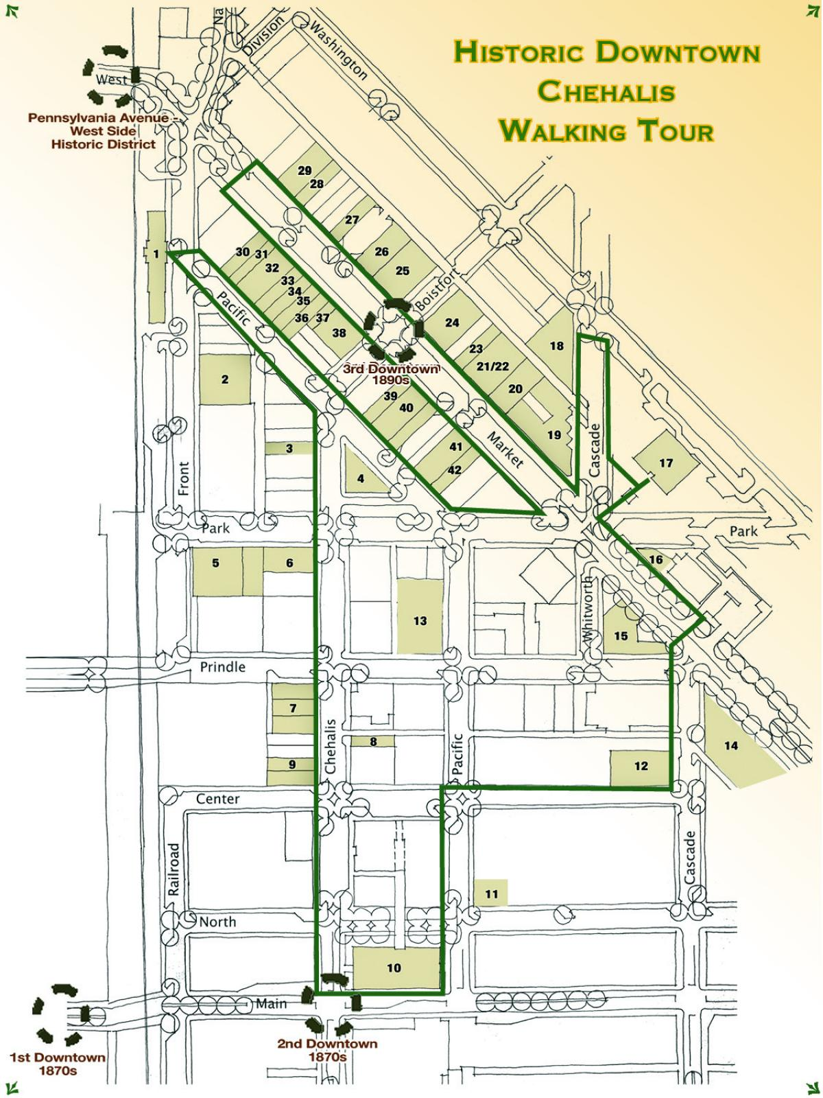
Figure 1

Historic Sites and Areas
The city of Chehalis has a rich history that is reflected in much of its architecture and many of its neighborhoods. Future patterns of land use and development must consider the community identity that is created by maintaining and preserving those sites and structures that remind citizens of their heritage. The city contains 2,588 buildings and structures listed on the Washington State Historic Property Inventory list, three districts and seven buildings that are listed on the National Register of Historic Places and Washington Heritage Register. These listings are largely the result of efforts by the Chehalis Historic Preservation Commission. The three districts are shown on the following pages and maps.
Most of the seven buildings listed independently on the National Register are also located within one of the three historic districts. The six buildings are described in detail below:
1. Burlington Northern Pacific Depot, 599 NW Front Street. This building is now the Lewis County Historical Museum. Built in 1912, this Mission Revival style building was once the area's center of transportation.
2. Obadiah B. McFadden House, 475 Southwest Chehalis Avenue. Built in 1859 of squared logs, this is the oldest residence in Chehalis. It is also believed to be the oldest continuously lived-in residence in Washington. This building is not within one of the three Historic Districts of Chehalis.
3. John R. Jackson House. It is located at Mary's Corner, 11 miles south of Chehalis on Jackson Highway. The house was built in 1845.
4. Osmer K. Palmer House, 673 Northwest Pennsylvania Avenue. This residence is one of the area's finest examples of the American Foursquare architectural style. It was built in 1910.
5. St. Helens Hotel, 440 North Market Boulevard. This downtown landmark was built between 1917 and 1920, to replace the original hotel built on this site in 1894.
6. United States Post Office, 225 Northwest Cascade Avenue. A Depression-era Works Progress Administration project dedicated in 1933, this building is a fine example of classical architecture and stone detailing.
7. Scout Lodge, 278 SE Adams Avenue. This meeting hall was completed in 1938 as part of the New Deal Works Progress Administration projects and was used as a meeting hall for a variety of organizations.

In addition to those buildings listed on the National Register, a number of additional buildings and sites have been identified locally as having historic significance and included in the maps of the districts are historic properties listed with the Washington State Department of Archaeology and Historic Preservation. Examples of these buildings include:

• Westminster Presbyterian Church, 349 North Market Boulevard. The oldest still existing non- federated Presbyterian Church in the Chehalis Valley, organized October 8, 1855.
• Royal Bakery, 242 Northwest Chehalis Avenue. The Royal Bakery, built in 1910, is representative of the commercial structures erected in the 'second' downtown along Chehalis Avenue and is one of the few existing buildings from that era that retains most of its integrity. Used primarily as a bakery, the structure has also been a barbershop, and an apartment building. In 1941, it became the area's first state liquor store. It is currently the Star Tavern.
• Advocate Printing, 429/431 North Market Boulevard. This commercial property was established in 1892.
• Talmadge Tufts House, 382 Southwest Cascade Street. This Cape Dutch style home, constructed in 1928, is noted for the 'door to nowhere.'
• Turner House, 120 Southeast Washington Street. This two-story brick colonial was designed by George Wellington Stoddard, a renowned Seattle architect, and constructed in 1939. It is believed that this home was Stoddard's last design outside the Seattle area.
• Fred Allen House, 670 Northwest Pennsylvania Avenue. This English Cottage home was built for Mr. Allen, superintendent of the Coal Creek Lumber Company, and his wife, between 1912 and 1915. The home is historically tied to the lumber industry as the residence of one of the more prosperous managers.
• Residence, 585 Southeast Washington Avenue. This is a well-maintained craftsman-styled bungalow.
• Daniel T. Coffman House, 647 Northwest St. Helens Avenue. One of the city's finest examples of the bungalow style, this house sits adjacent to a unique round barn with a domed roof. The barn and an accompanying carriage house were originally shared between this house and the one next door at:
• Noah B. Coffman House, 675 Northwest St. Helens Avenue. The original owner was the founder of the bank and the land development company that helped to shape the development of the city.
• Mill Worker Cottages, Prindle Street. Several modest homes were constructed on the north side of Prindle Street between 1905 and 1912, to serve as employee housing for a nearby lumber mill. These homes take on an interesting social and cultural significance when compared to the homes on Pennsylvania and St. Helens Avenues, which were built during the same period for mill owners and other community leaders.

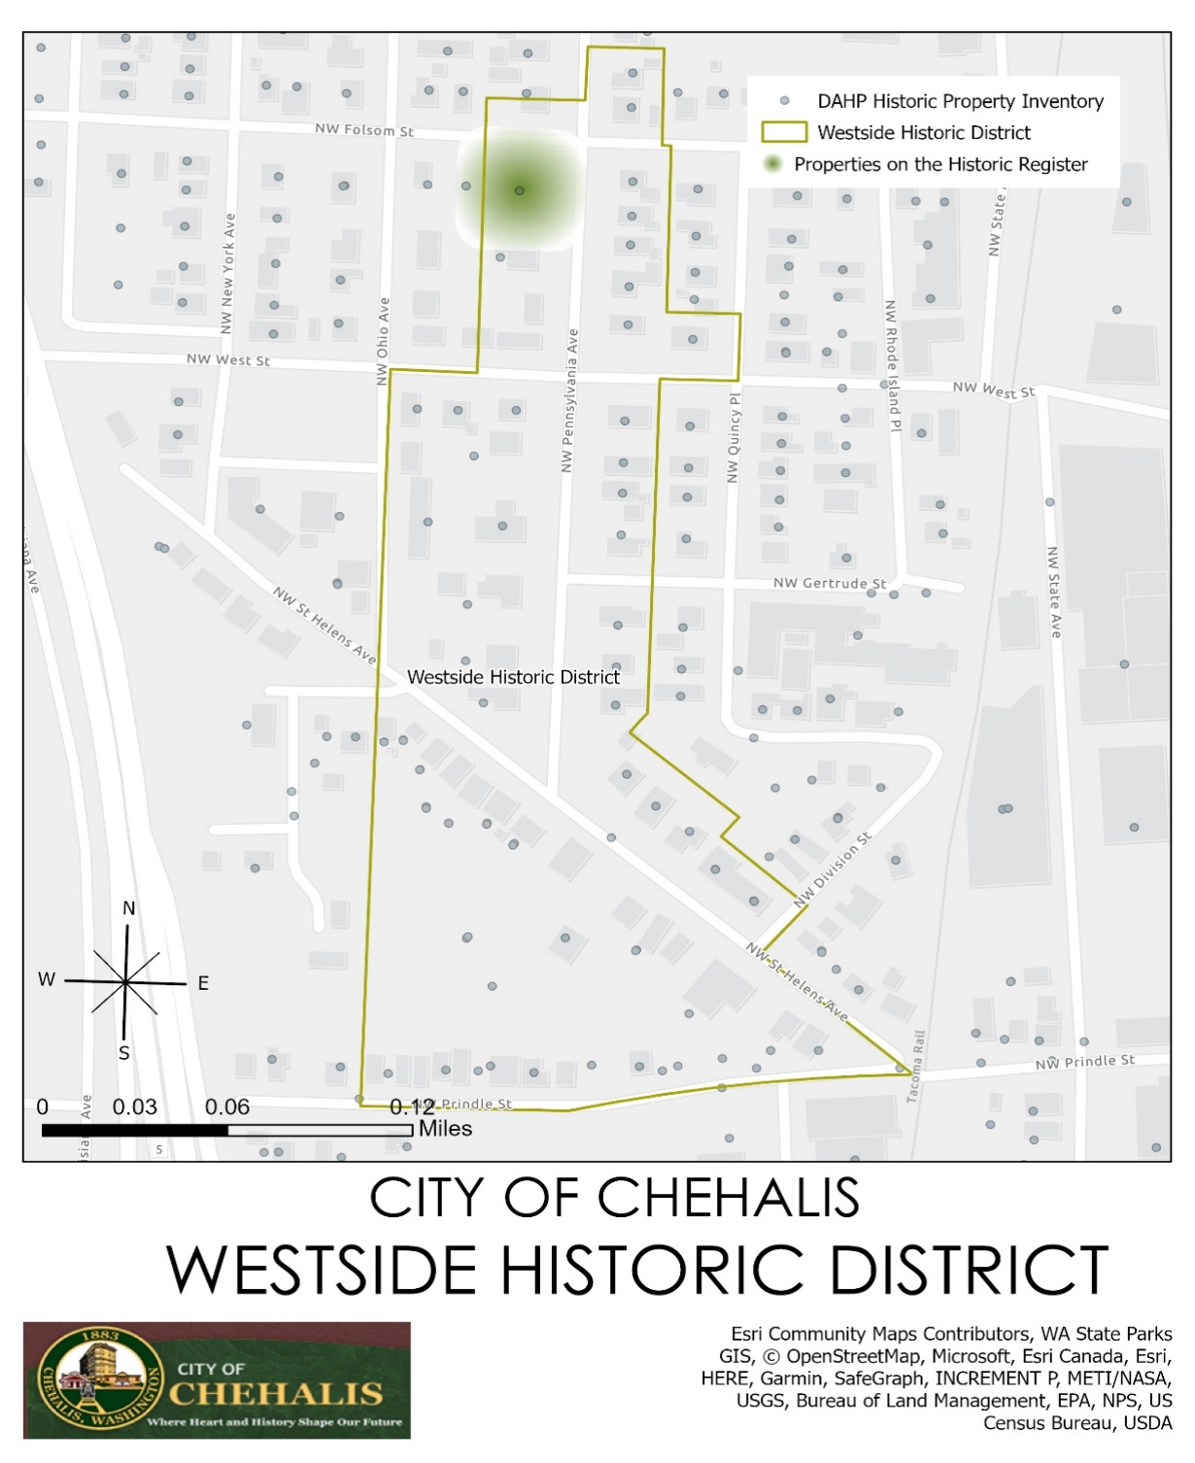
Figure 2
Westside Historic District
•West Side National Historic District. This district was entered into the National Register of Historic Places in 1992. The area includes Pennsylvania and St. Helens Avenues and features several blocks of antique streetlamps and elaborate homes from the carriage era. A total of 35 buildings within the district are considered significant. These buildings include commercial and residential structures, anchored by the former Burlington Northern Railroad Depot. The depot is now the home of the Lewis County Historical Museum.
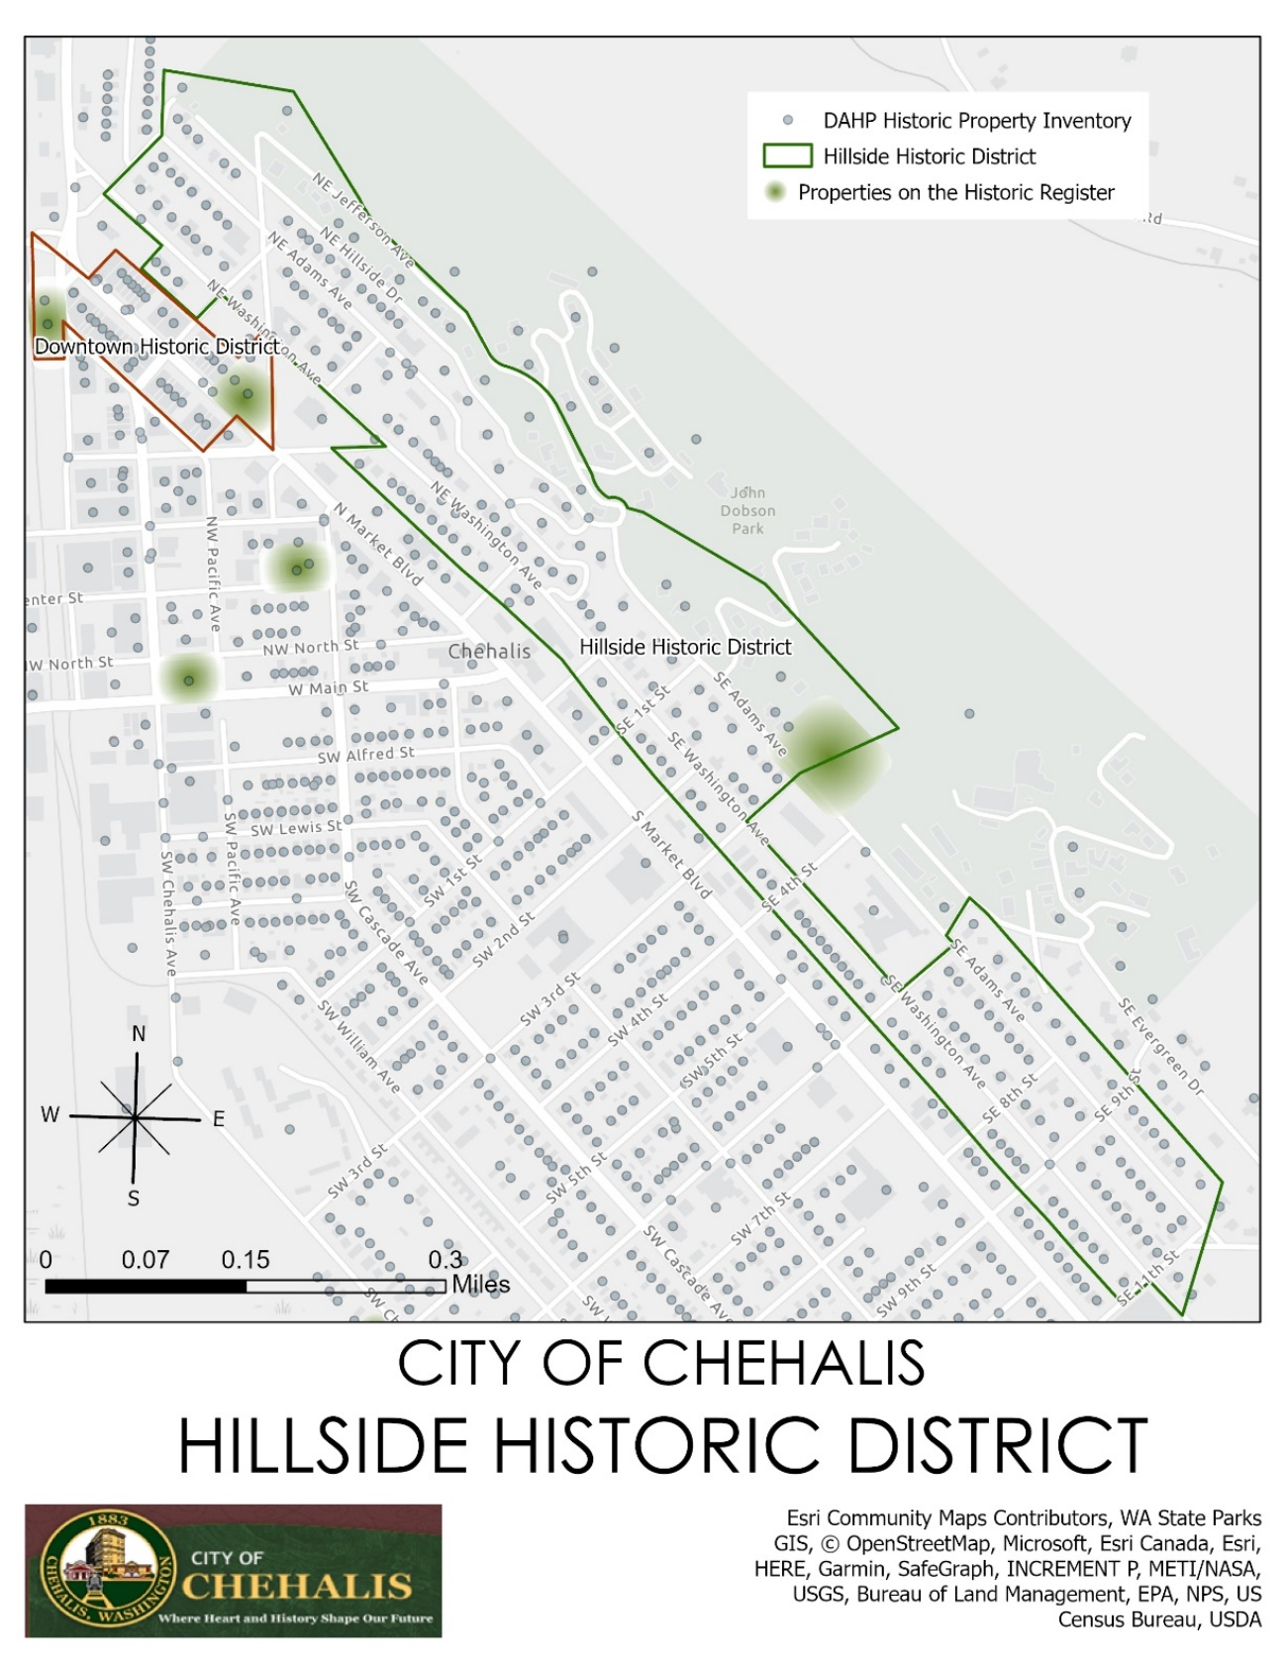
Figure 3
Hillside Historic District
•The Hillside Historic District. This district was entered into the National Register of Historic Places in 1996.
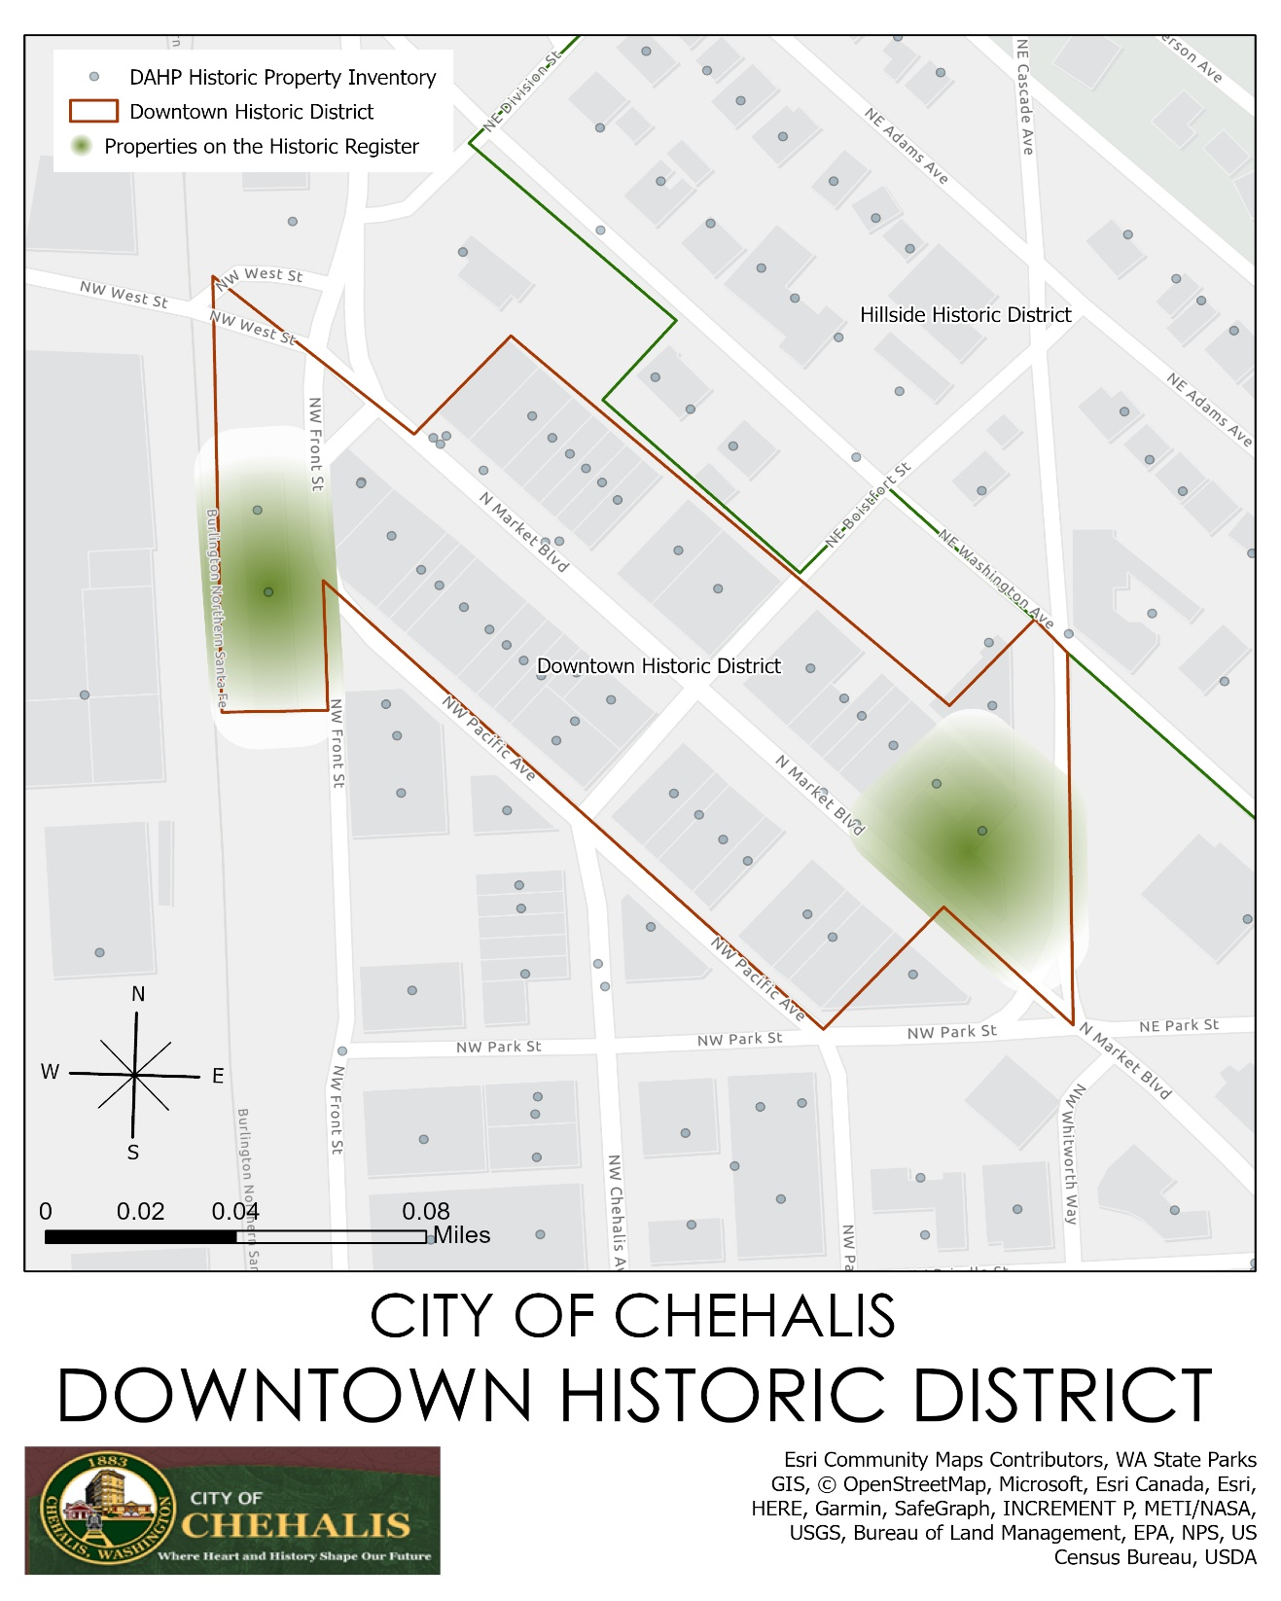
Figure 4
Downtown Historic District
•The Downtown Historic District. This most recent addition to the National Register of Historic Places (added in 1997) runs generally between Main Street and Market Boulevard. The district includes 21 significant buildings and traces the development of the downtown through three city centers.
Goals and Policies
Growth Management Act Goals
The pertinent GMA goals related to historical preservation, not listed in any order of priority, are:
- Historic Preservation. Identify and encourage the preservation of lands, sites, and structures that have historical or archeological significance. [2002 c 154 § 1; 1990 1st ex.s. c 17 § 2.]
- Economic development. Encourage economic development throughout the state that is consistent with adopted comprehensive plans, promote economic opportunity for all citizens of this state, especially for unemployed and for disadvantaged persons, promote the retention and expansion of existing businesses and recruitment of new businesses, recognize regional differences impacting economic development opportunities, and encourage growth in areas experiencing insufficient economic growth, all within the capacities of the state's natural resources, public services, and public facilities.

Countywide Planning Policies for Lewis County
Lewis County has adopted policies to guide local communities through the planning process, pursuant to their mandate under GMA. These policies are statements establishing a regional framework from which comprehensive plan elements for the county and its cities are developed. In general, these policies flow from the goals set forth in the preceding section. This plan is consistent with these policies. Policies that relate to this Historic Preservation element are as follows:
Historic Preservation. Identify and encourage the preservation of lands, sites, and structures that have historical or archaeological significance to Lewis County.
  - All jurisdictions are encouraged to work cooperatively towards identifying, evaluating, and protecting historic resources and encouraging land use patterns that protect and enhance such historic resources.

  - All jurisdictions should cooperate with local historic preservation groups to ensure coordination of plans and policies by the Washington State Office of Archaeology and Historic Preservation.

  - All jurisdictions should cooperate with local historic preservation groups to acknowledge and recognize historic sites, structures, and areas in their comprehensive plans, which have local importance, but may not formally be listed in the state and federal registers.

City Goals and Policies
Economic Development
Goal
HP.01 Encourage the return of businesses and former uses in historic areas.
Policies
HP.01.01 Recognize the positive economic impacts associated with visitors to the community by funding and participating in tourism marketing efforts with local historic societies.
HP.01.02 Provide financial incentives for the re-use and revitalization of dilapidated or vacant historic structures.

Natural Resource Industries
Goal
HP.02 Preserve and celebrate unique and culturally significant outdoor areas for recreation and tourism.
Policies
HP.02.01 Minimize the removal of existing vegetation when improving streets to preserve the natural character of historic districts or neighborhoods.

Open Space and Recreation
Goal
HP.03 Establish flexible zoning types to allow for more integrated and recreational community areas.
Policies
HP.03.01 Implement zoning and design standards to ensure appropriate and harmonious development around historic structures or areas.
HP.03.02 Allow for outdoor-space use by businesses in certain zones to encourage “patios” and other community-friendly uses that allow for more connection to the local environment.

Citizen Participation and Coordination
Goal
HP.04 Maintain city areas to encourage city pride and get citizens involved with community development.
Policies
HP.04.01 Increase community engagement with the historic districts and sites of Chehalis by developing stronger outreach through community events, public notices, and an online historic register that allows for community nominations.
HP.04.02 Encourage “sidewalk” events and markets in historic neighborhoods and districts by providing a simplified special event permit process.

Historic Preservation
Goal
HP.05 Recognize and maintain historic structures and sites and encourage new development to design in harmony with existing historic structures.
Policies
HP.05.01 Create and maintain a local register of historic places
HP.05.02 Designate historic landmark sites and structures, and review any proposed changes, to maximize the potential that such sites and structures continue to remain a part of the community.
HP.05.03 Work to ensure that new residential development provides the public facilities (pedestrian paths, landscaped areas, and other neighborhood improvements) necessary to integrate the new development in a way that maintains or improves the character, livability, and aesthetic quality of a historic district.
HP.05.04 Promote the maintenance and improvement of infrastructure and amenities within existing historic districts or neighborhoods through permitting incentives.
HP.05.05 Develop city procedures for identifying archaeological and historical sites of value.

.

