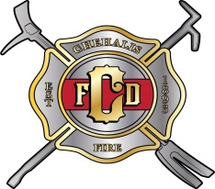
WELDING & HOT WORK PERMIT ATTACHMENT
Work is not permitted unless this is approved, signed and posted in work area
Applicant name:__________________________Company name:____________________
Contractor registration #:________________________expires:_______________
Detailed description of work to be done: ____________________________________________________________________________________________________________________________________________________________
Proposed Date of work: _____/_____/_____ Time(s) _____________AM/PM
How many Floors/Story’s? ___________Will work occur on Rooftop? Yes No (circle one)
What Special Precautions will be taken? ____________________________________________
Will Fire Watch be required? Yes No (circle one)
Signed_______________________________________________________
Individual responsible for work authorization (Facility Manager)
~~~~~~~~~~~~~~~~~~~~~~~~~~~~~~~~~~~~~~~~~~~~~~~~~~~~~~~~~~~~~~~~~~~~~~~~~~~~~~
Approval granted by: ___________________________________Title:____________________
Permit Expires _____/_____/_____ Time ____________PM
~~~~~~~~~~~~~~~~~~~~~~~~~~~~~~~~~~~~~~~~~~~~~~~~~~~~~~~~~~~~~~~~~~~~~~~~~~~~~~
FINAL CHECK (Where fire watch is required)
I do herby certify that the work area, and all adjacent areas where sparks might have spread, were continuously inspected during the entire time cutting, welding, or other hot work was conducted, and 30 minutes after completion. In addition, the work area was monitored every 30 minutes for four (4) hours after the cutting, welding, or other hot work was completed, and no fire conditions were noted.
Time Started _________________ Time Completed __________________
Signed _______________________________________________________

Return this permit, after work is completed, to the Chehalis Fire Department for record retention.
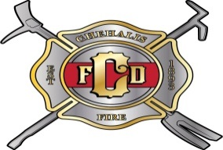
WELDING & HOT WORK PERMIT

CHECK LIST:
- Fire protection system(s) in service (sprinklers, CO2, foam).
- Cutting and welding equipment in good condition.
- Floor/ground clean (and wet down when necessary).
- Combustibles at least 35 feet from welding area.
- Flammable liquids and other hazards removed from area.
- All floor and wall openings within 35 feet covered.
- Non-combustible covers used to protect nearby combustibles and equipment.
- Containers, tanks, ducts, and other enclosures cleaned and purged of flammable vapors, liquids, dusts, and other hazardous materials.
- Fire extinguishers or small standpipe fire hose provided.
- All hazardous operations discontinued in area.
- Fire watch should be present during, and at least one-half hour after, welding or burning has ceased.
- Location of nearest fire alarm box identified. When possible, do work in a non-combustible area. An individual should generally be assigned to watch for dangerous sparks in the area and the floor below.

